**Project 2**

1. Project Description

In your first project, you were asked to implement the University database in MySQL. Many of you have done an excellent job. Figure 1 shows an ER diagram which is the same with the one in project 1.

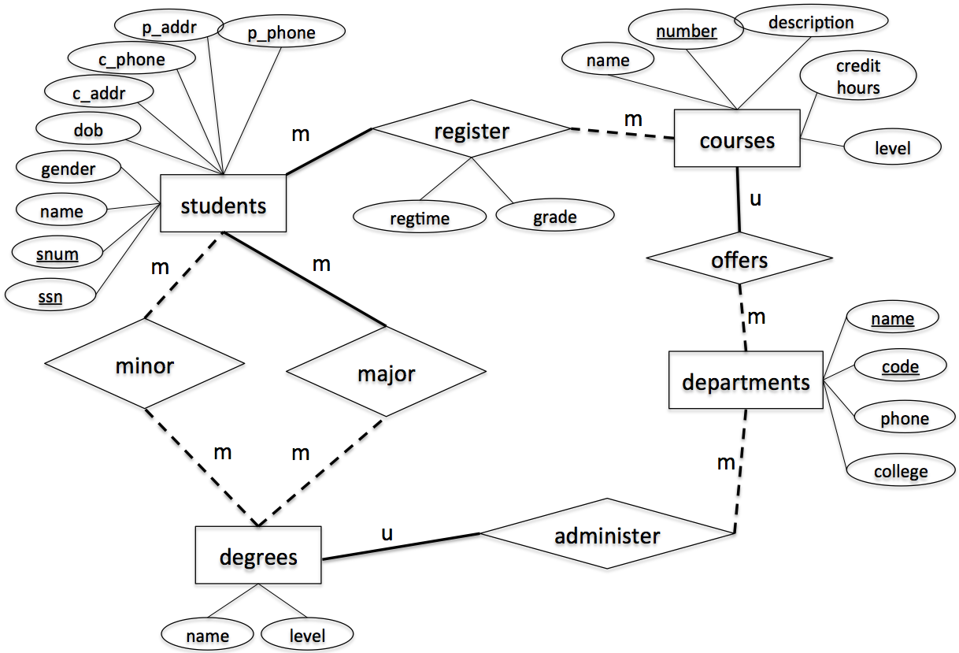

Figure 1. ER-diagram

This project is to implement the above design using a graphic model. Specifically, you are asked to write the following cypher scripts in Neo4J.

1. **ImportData.cypher [Points: 35]**

This script creates the graph database for the same information from Project 1. The tables are provided as csv files. You need to load those csv files into Neo4J to create nodes and edges.

1. **Query.cypher [Points: 45]**

This script prints out the following information

* 1. The student number and ssn of the student whose name is "Becky"
  2. The major name and major level of the student whose ssn is 123097834
  3. The names of all courses offered by the department of Computer Science
  4. All degree names and levels offered by the department Computer Science
  5. The names of all students who have a minor
  6. The count of students who have a minor
  7. The names and snums of all students enrolled in course “Algorithm”
  8. The name and snum of the oldest student
  9. The name and snum of the youngest student
  10. The name, snum and SSN of the students whose name contains letter “n” or “N”
  11. The name, snum and SSN of the students whose name does not contain letter “n” or “N”
  12. The course number, name and the number of students registered for each course
  13. The name of the students enrolled in Fall2020 semester.
  14. The course numbers and names of all courses offered by Department of Computer Science
  15. The course numbers and names of all courses offered by either Department of Computer Science or Department of Landscape Architect.

1. **ModifyRecords.cypher [15]**

This script modifies the following information

1. Change the name of the student with ssn = 746897816 to Scott
2. Change the major of the student with ssn = 746897816 to Computer Science, Master.
3. Delete all registration records that were in “Spring2021”,
4. **DropAll.cypher [5]**

This script deletes the database.

**Submission Instruction**

*Submit all your scripts to your Canvas account. Be sure to name your scripts as required, i.e., CreateGraph.cypher, Query.cypher, ModifyRecords.cypher, DropTables.cypher. you can copy your code from neo4j and save them in txt files, and then update the extension.*

Follow the videos on Canvas to set up neo4J 3.5.XX. Unzip the data.zip file and copy all files into neo4j-community-3.5.26/import directory.